Demonstration for EDCI 403

Grade 3 Science

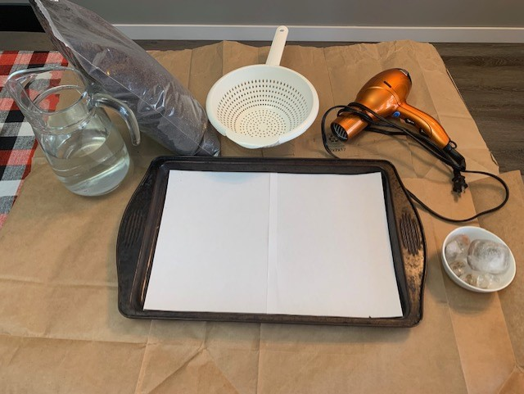By Jennie Thompson

**Big Ideas:** Water, wind, and ice change the shape of land

**Content:** Major local landforms, observable changes in the local environment caused by erosion and deposition by wind, water and ice

**Curricular Competencies:** Questioning and predicting: demonstrate curiosity about the natural world and make predictions based on prior knowledge. Processing and analyzing data and information-experience and interpret the local environment.

**Information on Demonstration and teacher notes:**

Landforms are always changing. Sometimes this happens slowly over millions of years, and sometimes it happens quickly. Landforms are shaped and continuously changed by water, ice and wind.

**Vocabulary:**

**Erosion**: earth materials being worn away or moved by natural processes like water, wind and ice.

**Weathering:** Static breaking down or dissolving of materials.

**Deposition**: Rocks and soil are moved and arrive in new places.

Teaching resources (Videos):

<https://education.nationalgeographic.org/resource/erosion/>

<https://education.nationalgeographic.org/resource/weathering/>

<https://youtu.be/ghC-Ut0fW4o> (how glaciers move slowly)

<https://youtu.be/oZZEJMtLOKU> How the Grand Canyon is formed (erosion: water, rain)

**Materials Needed:**

|  |  |  |
| --- | --- | --- |
| Power of **wind** demo Part A | Power of **water** demo Part B | Power of **Ice** demo Part C |
| Potting soil or sand  Hair dryer  Baking tray  White paper  Disposable gloves  Hard cover book or container lid | Water  Strainer  Potting soil or sand  Baking tray  White paper  Disposable gloves | Ice cubes frozen with a rock inside  Potting soil or sand  Baking tray  White paper  Disposable gloves |

**Steps for Demonstration:**

**Power of wind Part A:**

Step 1: Lay protective paper down on table for easy clean up (optional). Collect needed supplies.

Step 2: Place baking sheet on protective paper. Place white paper flat in cookie sheet (this makes it easier to see details of demonstration.

Step 3: Place 2-3 large handfuls of soil or sand on baking sheet. Form a mountain using hands (some students can use disposable gloves if there are some sensory issues).

Step 4: Once the mountain is formed, have students predict what will happen if the wind blows. Use a hard covered book or container lid to represent wind, flip up and down. Another demo could be using a hair dryer to represent wind. **Caution:** place the hair dryer on a low setting and bring toward the soil mountain. If the air setting is too strong cover with one hand and slowly remove hand.

Step 5: Have students record observations.

Students will see how the power of wind can move soil which then can change a land form.

**Power of water part B:**

Repeat steps 1-3 in power of wind if needed.

Step 1: Remold mountain out of soil or sand.

Step 2: Have student predict what will happen when it rains. Above the mountain slowly pour water through a strainer. Have students discuss observe the change in the soil (where it has moved). Explain to students that the water eroded or washed away part of the mountain changing its shape and that this can happen over time on a much larger scale to create landforms every where.

Step 3: Increase the amount of water poured through the strainer. Again, have students observe and record observation.

**Teacher notes: The wind may move the soil and water, new rivers may form, and the mountain may be eroded further by the wind and water moving.

**Power of Ice Part C**:

Step 1: Repeat steps 1-3 from power of wind, for a better effect make sure you use dry soil or sand, this will make the ice trail stand out.

Step 2: Place an ice cube (with a rock frozen inside) on the top of the newly formed mountain.

Have students record their predictions and observations. As the ice cube melts the rock may stay on top of the mountain or roll down creating erosion. This can represent snow melting through spring and summer creating rivers and erosion of the mountain or it may represent a glacier moving slowly eroding the land.

Teacher notes: Glaciers move downhill and outward under the weight of gravity. The movement is comparable to the movement of a river, but much slower. Glaciers can form on tops of mountains or in valleys. Constant thawing and refreezing causes fractures in bedrock and can deposit rocks far from their original location.

**Additional Teacher Notes**:

A note of discussion can be the 2021 flood where a section of highway 5 was washed away by the surging Coquihalla River near Hope BC. Floods and mudslides continued to have a severe impact on highways throughout southern BC

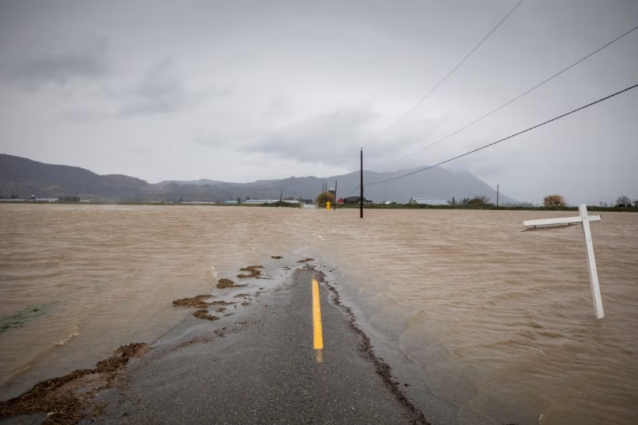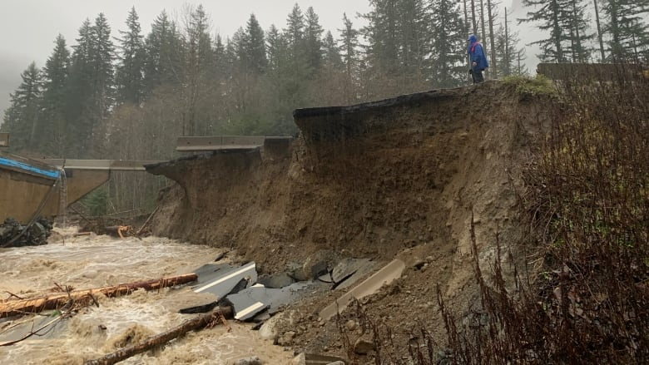

Indigenous Connection:

<https://youtu.be/cRKyUZTEptE>

Childrens book that tells the story of the draining of Sumas Lake from an Indigenous perspective.

References

BC Curriculum: <https://curriculum.gov.bc.ca/curriculum/science/2/core>

CBC News. Coquihalla highway and Sections of Hwy 1 Closed Do To Major Flood Damage. (November 15, 2021). <https://www.cbc.ca/news/canada/british-columbia/coquihalla-trans-canada-highway-damage-1.6250235>

Wind, Water, and Landforms. (ND). Discover the power of water, ice and wind to move mountains. (Ideas for this demonstration came from) <https://schools.bchydro.com/?gclid=Cj0KCQiAnrOtBhDIARIsAFsSe51244ZnUv2SO0sza4h2_rcBTo3Il6Eh9tm6eCVJaCsUFMLpD6AW4LYaAnQTEALw_wcB>